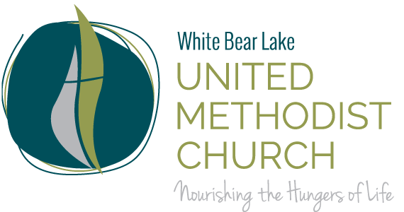

Alleluia Ringers Spring 2022 Schedule Playing for Traditions – 9am*
January 16 “We Three Kings” arr. By S.E. Fauble
February 20 “Prayer for the Innocents” by Michael Helman
“Do Lord” arr. By Valerie Stephenson
March 20 “Peace in Our Time” with violin Cara Wilson
April 15 “In Adam We Have All Been One” arr. By Scott M. Hyslop
“When Jesus Wept” arr. By Karle Erikson
April 17* “Now the Green Blades Riseth” Kevin McChesney
Hymn tba
May 15 “Do Lord” arr. By Valerie Stephenson
Small ensemble piece

* Exception EASTER play at the 8:30am & 9:45am worship services.

Joint Concert Alleluia Ringers and Bells of the Lakes
May 15 4:00pm at WBLUMC

“Jesu, Joy of Man’s Desiring” arr. Bill Mathis
“Antiphonal Flourish” arr. Bill Mathis
“Gladness and Grace” Michael Mazzatenta
“Peace from our Time” or “Prayer for the Innocents”

Sectionals 5pm – 5:30pm

Recording Session for Online Worship
February 9
March 30

General info:
- Rehearsals are Wednesday from 5:30pm – 6:45pm
- Performances-3rd Sunday of each month Oct-May.
  - 2022: 1/16, 2/13, 3/13, 4/17, 5/15
  - No rehearsal: 11/24, 12/22, 12/29, 3/2
  - Last rehearsal 5/11

Community Ringing Events
- BellFest 2/26/22 at North Heights Lutheran Church in Arden Hills.
  - Registration deadline 12/31/21
- Area 7 Festival Handbell Musicians of America at DECC, Duluth, MN

Peteria’s cell (612)251-3861 text ok

Version 2/23/22

