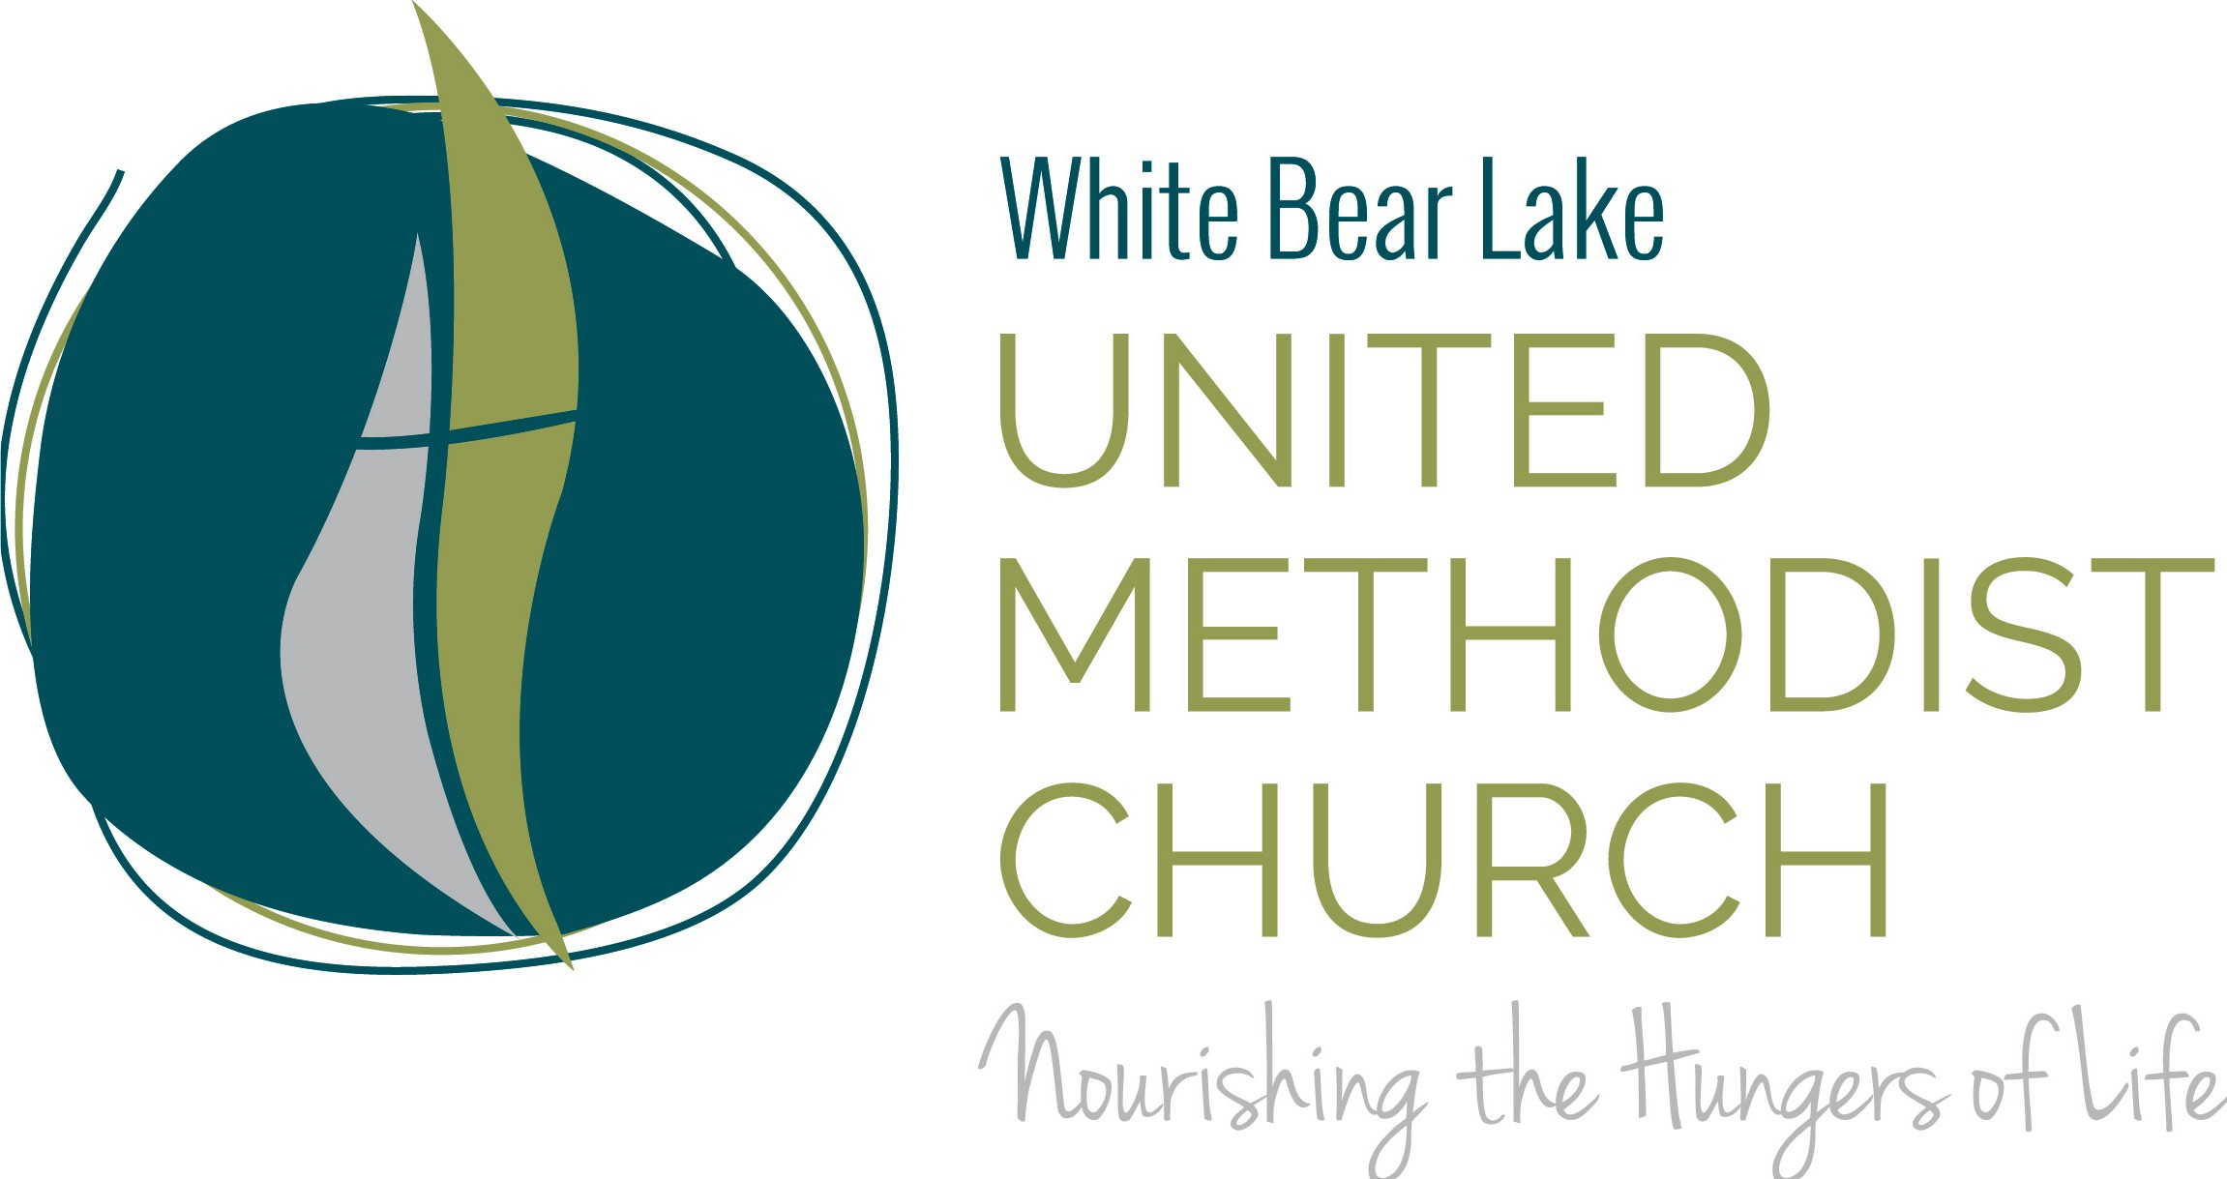

Next Generation Minister
Next Generation Minister: Opportunity for individual to contribute to a vibrant congregation and support our vision. This role is focused on children and youth ministry.

Purpose: The Next Generation Minister connects and attracts children, youth and their families and helps them learn and apply Christ’s teachings to their lives, the church and the larger world.

Roles and Responsibilities:
- Actively reach out to families of children and youth and engage them in meaningful ways.
- Lead and help grow the children and youth program (birth through Sr. High), including Sunday morning education, Wednesday night programming, and special events
- Adapt programming to the current and changing environment based on state guidance during the COVID-19 pandemic
- Use various platforms to teach and engage children and youth (video, remote meetings, social media, etc.)
- Recruit, train, support and supervise volunteer teachers and assistants.
- Manage nursery care for Sunday mornings and special events
- Develop engaging curriculum that aligns with the mission of the United Methodist Church
- Develop programs that support the spiritual growth and unique life journeys of our children and youth, including mission trips and retreats.
- Champion the next generation in our church and facilitate vital relationships with God, each other, and the broader community.
- Engage our members and larger community in intergenerational learning and social action initiatives.
- Attract new children and youth into our church community.
- Design and teach confirmation program
- Serve as staff liaison to specific church groups and projects

Gifts and Talents

The Next Generation Minister is a Christ-follower who seeks to grow daily in his/her spiritual life and share the love of Christ with others. Specific talents include:
Leader:
Gifted in leading children of all ages, youth, and their families. Understands the needs of children and youth and can engage them in spiritual growth and the life of the church.
Flexibility and Creativity:
Ability to adapt to the changing needs of children, families and volunteers, and develop new ways of teaching and engaging them.

Preacher/teacher:
Able to preach, teach and lead groups. Can convey a personal and relevant message that speaks to every age.

Intergenerational:
Is able to understand the spiritual needs of children and youth and bridge the gap between older-younger generations.

Outreach:
Builds relationships, actively utilizes social networks and delivers high-interest programs for children and youth.

Technological Knowhow:
Comfortable with various technology platforms (MS Office products, Zoom, etc.) and able to use technology creatively to engage youth.

Organizational Skills:
Able to plan, develop, organize and successfully implement new programs. Able to maintain a consistent system to effectively run activities using volunteers. Is a self-starter and follows through on details required for success.

Education: Minimum Bachelor’s degree. Master’s degree preferred.

Accountable to: Senior Pastor

Experience: 3 – 5 years minimum working with groups, motivating and engaging others, and developing youth and family programs.

Senior Pastor Bill Eaves
White Bear Lake United Methodist Church 1851 Birch Street, White Bear Lake, MN, 55110 651-429-9026

office@wblumc.org

